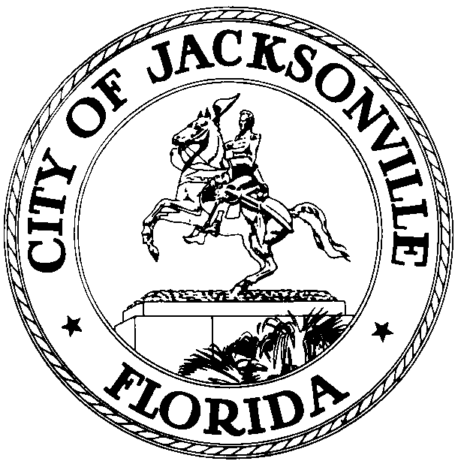
OFFICE OF MAYOR LENNY CURRY

ST. JAMES BUILDING  117 W. DUVAL STREET, SUITE 400  JACKSONVILLE, FL 32202 |  | PH: (904) 255-5000  FAX: (904) 255-5032  www.coj.net

March 24, 2020
(12:30 P.M.)

**CANCELLATION***
MEETING NOTICE

Notice is hereby given that Mayor Lenny Curry is hosting a conference call with members of the Jacksonville City Council. The meeting will be held on Tuesday, March 24, 2020, at 3:00 P.M., and will be hosted virtually through the Zoom app. In an effort to encourage social distancing and in accordance with Gov. DeSantis’ Executive Order Number 20-69, “Local government bodies may utilize communications media technology, such as telephonic and video conferencing, as provided in section 120.54(5)(b)2., Florida Statues.”

The purpose of this meeting is to provide updates about the novel coronavirus (COVID-19) to the members of the Jacksonville City Council.
Information regarding the Zoom meeting ID and meeting password is listed below.
Meeting ID:695665858
Meeting Password:022793

Please join the meeting by 2:50 P.M.

This meeting has been cancelled.

Please contact Jordan Elsbury, Director Intergovernmental Affairs, by email at JElsbury@coj.net or by phone at 904.255.5013.

LC/je

XC: Council Members/Staff Jessica Matthews, Chief of Leg. Svcs.
Crystal Shemwell, Sr. Manager Leg. Svcs. Peggy Sidman, Deputy General Counsel
Paige Johnston, Assistant General Counsel Cheryl L Brown, Council Secretary
Jason Gabriel, General Counsel Jeff Clements, Chief of Research
Kristi C. Sikes, Chief of Administration CITYC@COJ.NET
Electronic Notice Kiosk- 1st Floor City Hall Public Notice System-Council Webpage
Kyle Billy, Council Auditor Kim Taylor, Asst. Council Auditor
Media and Media Box File Copy

